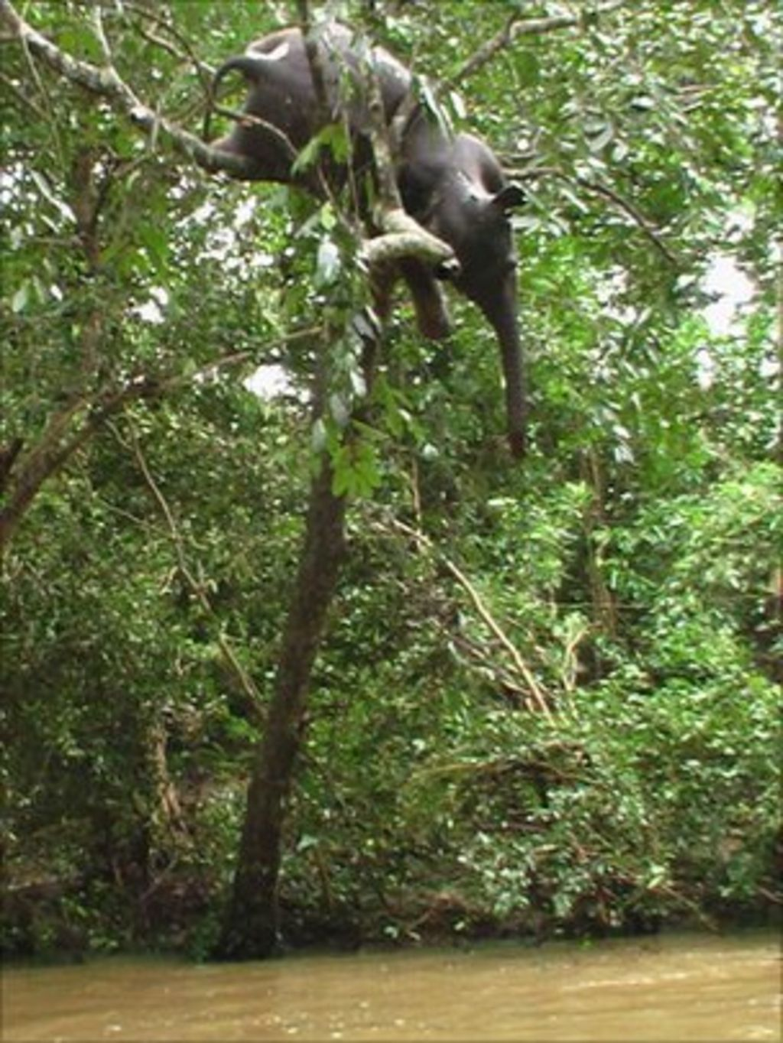
Trees Are Amazing

Trees survive high winds, floods, and cold winters. They can even save elephants!

Write a story about what happened in this picture.

