Fractions, Decimals, & Percents

Fractions, decimals, and percents all represents parts of a whole. For instance, half an apple can also be referred to as .5 or 50%. There are advantages and disadvantages to each way of representing parts of a whole. For instance, fractions tell you how many pieces were in the original whole. In the following situations, decide whether you would choose to use a decimal, a percent, or a whole, and explain why.
Logical Mathematical

- A sale on winter jackets
- Changing money from Canadian dollars to American dollars
- Sharing a pizza
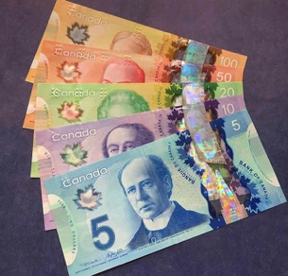
- Comparing population statistics

