Fractions

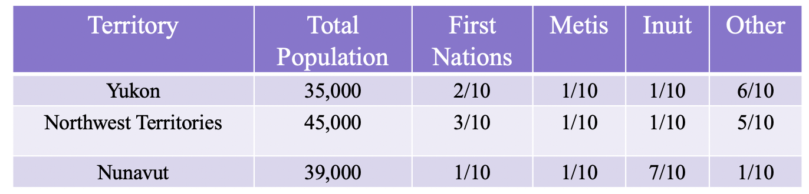
Logical Mathematical

Create a concrete, pictorial, and symbolic representation of the population of the Canadian North. Explain how your projects show the different people in the North, how many there are, and what the differences are between the territories.
