Natural Selection

Charles Darwin was a scientist who studied how animals evolve over time. He noticed that animals who have physical characteristics that best adapt to the environment survive, and reproduce, while others die out. For instance, an animal with thick fur might not survive as the earth’s temperatures get warmer, and animals with thinner fur will survive and reproduce. As a result, over hundreds of years, some species go extinct, others change their physical characteristics, and others thrive and become more populous.

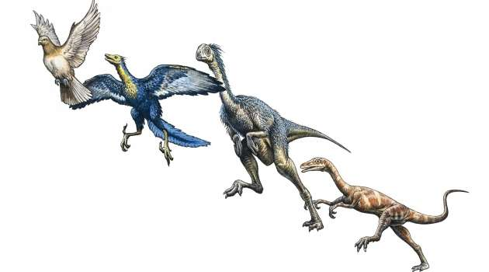
Choose a dinosaur. If they first had to survive the ice age, then adapt as the earth warmed up, and now had to survive global warming, how might they have adapted over time? Draw your dinosaur as they existed originally, during the ice age, in the 1800s, now, and in the future.

