Physical & Chemical Change

Physical changes are when something looks, smells, or feels different, but is still made of the same thing. Melting ice is a physical change – it looks different, but it is still just water.
Chemical changes are when something changes what it’s made of. When we bake a cake, we mix several ingredients into one new thing – the cake.
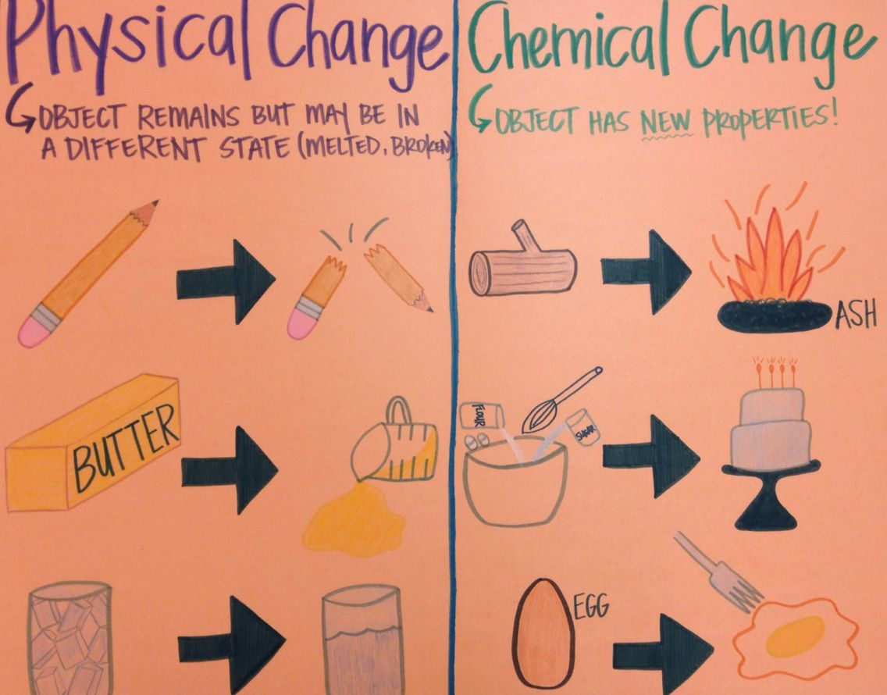
Think about the things you do in a day, like making toast for breakfast, brushing your teeth, and drawing a picture.
Are these physical or chemical changes?
Think of three more things you do, and decide if they are physical or chemical changes.

